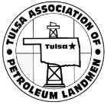

2019 TAPL Spring Seminar
April 25, 2019

TO: All TAPL Members and Interested Sponsors
RE: 2019 TAPL Spring Seminar Sponsorship

Dear Friends:

The Tulsa Association of Petroleum Landmen is pleased to announce its 2019 Spring Seminar. The event is scheduled for Thursday, April 25, 2019, in Perkins Auditorium at the OU Tulsa Schusterman Center located at 41st and Yale in Tulsa, OK. We will be sending registration forms for this event in the next few weeks and expect maximum attendance.

Our speakers will cover an array of topics that will benefit the Landman and Attorney. Our last speaker of the day will be Mr. Kenneth Wagner. Mr. Wagner is the newly appointed Secretary of Energy and Environment for the Great State of Oklahoma.

We are very appreciative of the numerous companies and individuals who have helped sponsor this event in the past and who have helped make this event one of the best educational seminars in the state. We currently have several companies, who are listed below, that have already generously agreed to sponsor the Spring Seminar. I ask for your support in making the Spring Seminar a continued success. As always, our sponsors will be recognized for your support of TAPL through signs, announcements, and/or the TAPL website.

If you would like to help sponsor this event, please complete and return the following sponsorship form with your check payable to “TAPL”, to:

Titanium Exploration Partners, Inc.
ATTN: Mariena Martin, RPL
320 South Boston, Suite 1000
Tulsa, OK 74103

We ask that you please respond no later than April 12, 2019. Thank you for your past support and consideration of sponsoring this event. Should you have any questions, please contact Jim Slade at 918-894-4469 (jslade@bravonr.com) or Mariena Martin at 918-984-4837 (martin@titaniumep.com).

Sincerely,
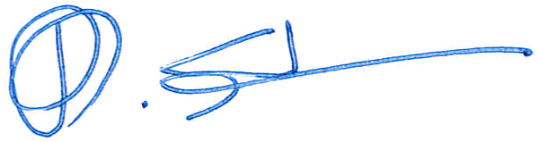

Jim D. Slade, CPL, TAPL Education Director

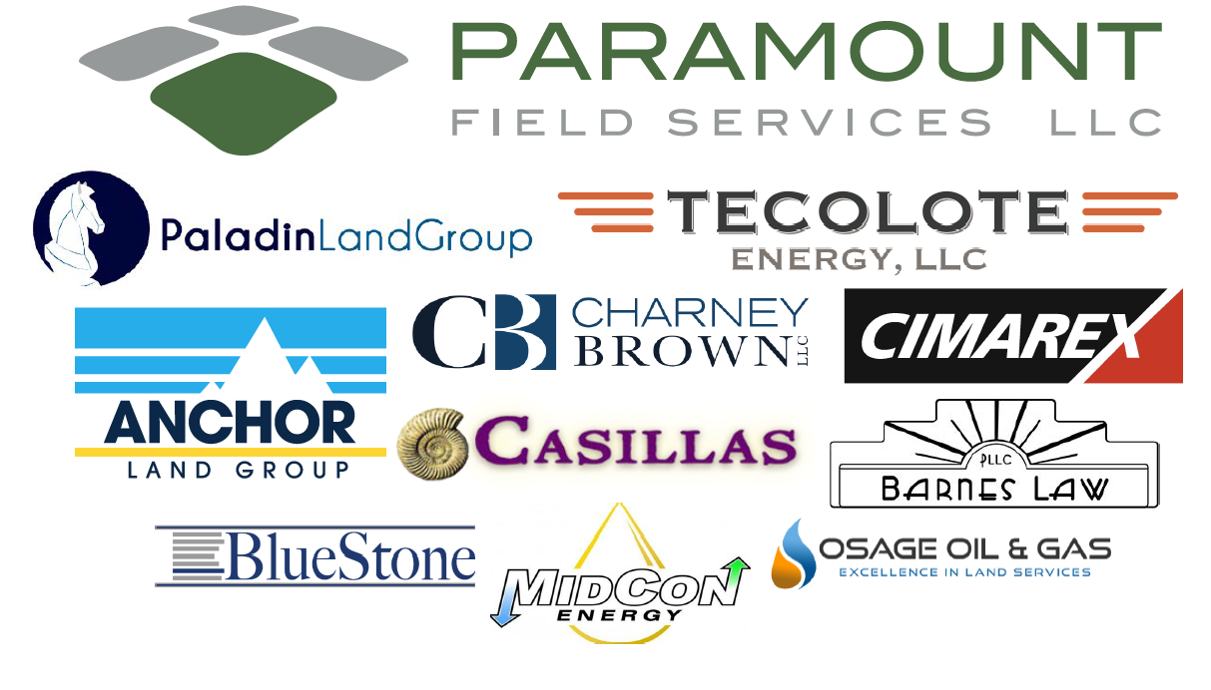

2019 TAPL Spring Seminar
Sponsorship Form

_____________________________________ would like to be a sponsor of the 2019 TAPL Spring Seminar.

Sponsorship Amount: ____________________________________

Company/ Individual Contact: _______________________________________

Contact Phone: _________________________________________

Contact Email: ____ ______________

Sponsorship Name to be displayed:
(If applicable, please email your logo to palaback@bravonr.com)

If Paying with Credit Card, please fill out the information below:

Credit Card Provider (Please Circle One): VISA MASTER CARD AMEX DISCOVER
A 3% processing fee will be added to transaction amount.

Card Number: ______________________________________________ Exp. Date: ______________________

Name on Card: ____________________________________________ CVV Number: ____________________
(3 or 4 Digit Code)

Authorized Signature: _________________________________________ Amount: $________________________

By providing this information and your Authorized Signature, you are authorizing TAPL to charge the credit card provided for the amount provided plus a 3% processing fee.

