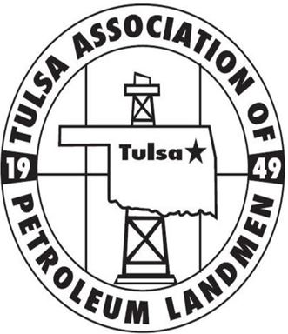
TAPL SPRING SEMINAR
THURSDAY, MAY 3, 2018

Perkins Auditorium | Schusterman Learning Center, OU-Tulsa | 4502 E. 41st St Tulsa, OK 74135
Registration/Check-in opens at 8:00 am| Event will run from 8:30 am-4:00 pm

The TAPL Education Committee is proud to announce our 2018 Spring Seminar. We’ve selected an excellent array of speakers, each a professional well-versed in their respective area of expertise.
Our committee has worked hard on the behalf of our membership to secure a lineup that we are confident will benefit the full spectrum of our membership. We have requested approval from the AAPL for 6 RL/RPL/CPL credit hours, including 1 ethics credit as well as CLE credits from the Oklahoma Bar Association.

EVENT SUMMARY
8:00 am – 8:30 am: REGISTRATION (coffee & donuts)
8:30 am – 8:40 am: WELCOME/ OPENING REMARKS
8:40 am - 9:45 am: HOT TOPICS IN BIA/BLM REGULATIONS
Reagan Smith Energy Solutions will provide three of their experts, Monica M. Griffin, President & CEO, Scott St. John, VP of Environmental Compliance & Engineering and Jennifer E. Krieg, VP of Land & Regulatory Compliance will update membership on several of the recent hot topics and developments regarding BIA and BLM regulations such as possible changes in Five Civilized Tribe leasing, BLM leasing, BLM logging and BOP requirements.

10:00 am - 11:00 am: OK & TX REGULATORY COMPARISON (Allocation wells, multiunits)
Benjamin Holliday, J.D./MA will provide attendees with an overview of Oklahoma’s Forced Pooling and a more in-depth discussion of Texas’ Allocation Wells as a means for comparing and contrasting these regulatory approaches to maximizing hydrocarbon recovery. Ben will review the contentious history of Allocation Wells in Texas, the mechanics of their use, and highlight the main issues surrounding their unsettled legal status.
11:00 am - 12:00 pm: ADVANCED TITLE ISSUES PANEL
- Kaycee Spears Boren – Attorney at Pray Walker, P.C.
- Faith Orlowski – Attorney at Moyers Martin LLP
- Jacob Charney – Attorney at Charney|Brown LLC
- Rami Jabara – Of Counsel at Charney|Brown LLC

Oil and gas title opinions have continued to become more complex over time. TAPL’s education committee has gathered a panel of experienced title attorneys to discuss some of the more perplexing issues that have become increasingly prevalent in the scope of mineral title examination. The first segment of our panel will provide an overview of some challenging topics as well as the related legal questions that remain unanswered by the Oklahoma Supreme Court. Why are leasehold rights affected in the context of river units? How is ownership allocated in the presence of a railroad? The panel will also touch on some of the more difficult questions surrounding multi-section units at the time a division order opinion is rendered. The floor will then be open to any title related questions for our panelists.
12:00 pm - 1:00 pm: CATERED LUNCH (Lambruzco’z box lunch)
1:00 pm – 1:45 pm: SENATE BILL 867

Ben Brown, Esq. with Charney/Brown, LLC and John Chandler, Esq. with Michael D. Stack, PC will walk us through the new Senate Bill 867 legislation and the new statutes impact on OCC filings. In particular, Ben and John will provide an overview of the new statute and compare and contrast the new rules vs. how things were done previously.
2:00 pm - 3:00pm: PRODUCTION IN PAYING QUANTITIES
Keith Needham, CPL/J.D./MBA will provide attendees with a current overview of Oklahoma’s law on production in paying quantities and the various quiet title/lease cancellation suits that can be brought by mineral owners, top lessees, etc. Keith’s firm has a case pending in the OK Supreme Court which has the opportunity to finally provide some much needed “clarity” on the topic as Oklahoma’s law has been a little vague/ambiguous for nearly 25 years given certain Supreme Court decisions.
3:00 pm – 4:00 pm: ETHICS PRESENTATION: “WHEN MINERAL BUYERS HAVE A DUTY TO DISCLOSE”
Jason Baker with Jason D. Baker, Attorney at Law. P.C. will provide an overview of when a mineral buyer may have an obligation to disclose known facts about the asset to the seller.

Best regards, and on behalf of the TAPL Education Committee, we look forward to seeing you on May 3rd.

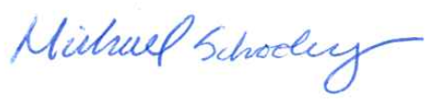
Michael Schooley, CPL
Education Director

