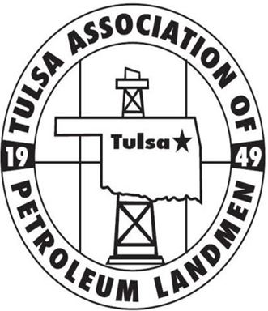
TAPL SPRING SEMINAR
THURSDAY, APRIL 13TH

Perkins Auditorium | Schusterman Learning Center, OU-Tulsa | 4502 E. 41st St Tulsa, OK 74135 Registration/Check-in opens at 8:00am| Event will run from 8:30am-4:00pm

The TAPL Education Committee is proud to announce our 2017 Spring Seminar. In selecting topics for this year’s seminar, we’ve sought to address some traditional subjects that will assist the land professional in navigating common challenges faced in our line of work. We’ve also sought to educate our membership on trends that are re-shaping activity in the Mid-continent region. We’ve selected an excellent array of speakers, each a professional well-versed in their respective area of expertise.
Our committee has worked hard on the behalf of our membership to secure a lineup that we are confident will benefit the full spectrum of our membership. We have requested approval from the AAPL for 6 RL/RPL/CPL credit hours, including 1 ethics credit as well as CLE credits from the Oklahoma Bar Association.

EVENT SUMMARY
8:30am – 8:45am: WELCOME/ OPENING REMARKS
8:45am - 9:45am: “COMMUNITIZATION AGREEMENTS AND BIA/BLM PERMITTING”
Our opening segment will address communitization agreements, BLM permitting, and the current regulatory environment related to BLM and BIA issues. An understanding of what is required to develop your Federal/Indian leasehold and the timing involved is critical for a landman in order to stay ahead of the rigs while preparing drilling locations. Reagan Smith Energy Solutions will provide two of their experts, Scott St. John, VP of Regulatory Compliance and Nelson Anaback, Senior Federal Unit Specialist, to educate us on these topics.

10:00am - 11:00am – LEASE MAINENTANCE: “HOW H’d IS THAT HBP LEASE?”
In times of industry downturn, maintaining lease inventory becomes a particularly difficult task as weak market conditions and budget restrictions act to hinder the proper development of leases. When making acquisitions that include producing properties, the landman must always be wary of the term “held by production” and ensure that the production/operations on each property have been sufficient to maintain associated leasehold. Professor Keith Sellers, an attorney with Sellers Law Firm, P.C., and Adjunct Professor of Law with the University of Tulsa with 36 years of experience in oil and gas law, will educate us on the topic of lease maintenance and what is required to hold a lease, as well as what is required to assert that a lease is no longer held by production.
11:00am - 12:00pm: OCC UPDATE: “LIFE AFTER FAIRFIELD”
Ben Brown, Esq. of Charney, Baker & Brown and Grayson Barnes Esq., of Barnes Law Tulsa- two of Tulsa’s premier oil and gas regulatory attorneys will discuss recent developments at the Oklahoma Corporation Commission such as the “Continental v. Fairfield Minerals Decision”, a very important ruling with implications that must be properly understood by all Mid-Continent landmen working Oklahoma. Our speakers will lend their expertise to provide an interactive presentation on the “Fairfield Decision”, encouraging questions from the audience to ensure all perspectives are addressed.
12:00pm - 1:00pm – CATERED LUNCH
1:00pm - 3:00pm (w/ 15-min break): PRIVATE EQUITY PANEL

The massive infusion of private equity investment into US oil and gas plays over the last several years has undeniably reshaped our industry. In the wake of the 2014 oil crash that shuttered many large corporate offices in cities like Tulsa, scores of PE-funded startups have exploded onto the scene equipped with hundreds of millions of dollars to pump into the market, becoming a prominent feature of the energy landscape.

So let’s learn about how all these startups get funded.

TAPL’s education committee has gathered a panel of speakers representing top Private Equity firms and Energy Advisories. The first segment of our panel will explore the basic roles of private equity providers and investment advisory services in the upstream development process, particularly as it applies to the Mid-continent region. We will then host a moderated discussion panel on topics ranging from deal structures, what goes into selecting portfolio companies, networking, exit strategies and more. We encourage engagement from the audience then open up for a Q&A opportunity.

Panel Speakers:
- Patrick J. Lissonet - Senior Vice President of Kayne Anderson Energy Funds
- Lindsay Sherrer - Co-Founder of TenOaks Energy Advisors
- Drew Wellsfry – Vice President of EnCap Investments, L.P.
- Additional EnCap speaker TBA

3:00pm - 4:00pm – ETHICS PRESENTATION
“Always do right. That will gratify some people and astonish the rest.” -Mark Twain
We work in an industry in which many of us will be faced with dubious situations throughout our career. Ethical guidelines and rules for landmen are set by the American Association of Professional Landmen (“AAPL”), the largest trade association of landmen in the country. Fortunately for us, Scott Stone of Spartan Resources, a former AAPL President, will speak to us about maintaining our professional integrity as we navigate ethical dilemmas that can appear in shades of gray rather than black and white.

Best regards, and on behalf of the TAPL Education Committee, we look forward to seeing you on April 13th.

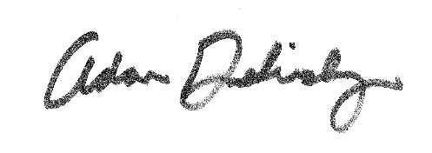
Adam Dolinsky, CPL
Education Director

